Accident / Incident Investigation Report

Instructions: Complete this form as soon as possible after an incident that results in serious injury or illness. (Optional: Use to investigate a minor injury or near miss that could have resulted in a serious injury or illness.)

This is a report of a:  Death  Lost Time  Dr. Visit Only  First Aid Only  Near Miss
Date of incident: | This report is made by:  Employee  Supervisor  Team  Final Report

Step 1: Injured employee (complete this part for each injured employee)
Name: | Sex:  Male  Female |  | Age:
Department: | Job title at time of incident:
Part of body affected: (shade all that apply)  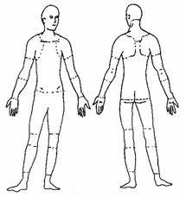 | Nature of injury: (most serious one)   Abrasion, scrapes   Amputation   Broken bone   Bruise   Burn (heat)   Burn (chemical)   Concussion (to the head)   Crushing Injury  Cut, laceration, puncture   Hernia   Illness   Sprain, strain   Other ___________ | This employee works:   Regular full time   Regular part time   Seasonal   Temporary
Months with
this employer
Months doing
this job:

Step 2: Describe the incident
Exact location of the incident: | Exact time:
What part of employee’s workday?  Entering or leaving work  Doing normal work activities
❑ During meal period  During break  Working overtime  Other
Names of witnesses (if any):

